POWERBI PROJECT

Digital Student Life

Student Habits and Academic Performance Analysis – Power BI Project

This project focuses on analyzing the relationship between students’ daily habits and their academic performance using Power BI. The dataset includes factors such as study hours, attendance, sleep patterns, social media usage, extracurricular activities, and exam scores. Interactive dashboards and visualizations were created to identify trends, compare student behaviors, and evaluate how different habits impact academic outcomes. The project demonstrates skills in data cleaning, data modeling, DAX calculations, and dashboard design while providing meaningful insights to support data-driven educational decisions.

Various Filter to get the data
- Total Students
It shows the total number of students in the dataset.
Total Students = DISTINCTCOUNT('Student Habits and Academic Per'[student_id])
Used the Card Visual.
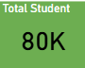

- Total Semester
It shows the total number of semesters in the dataset by selecting the total distinct count of semester column.
Used the Card Visual.
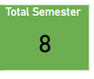
- Average Mental Health
It shows the Average Mental Health in the dataset by selecting the average mental
health option column.
Used the Gauge Visual.
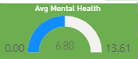

- Avg Stress Level
It shows the Average Stress Level in the dataset by selecting the average Stress Level option column.
Used the Gauge Visual.
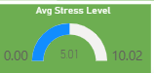

- Avg Study Time
It shows the Average Study Time in the dataset by selecting the average Study Time
option column.
Used the Gauge Visual.
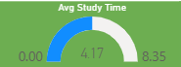

- Major Subjects List Filter
Used the Slicer Visual.
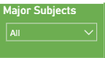

- Parental Education List Filter
Used the Slicer Visual.
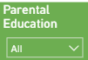

- Dropout Risk Tile List Filter
Used the Slicer Visual.
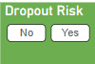

- Family Income Status Filter
Used the Slicer Visual.
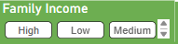

- Gender Filter
Used the Slicer Visual.
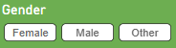

- Diet Quality Filter
Used the Slicer Visual.
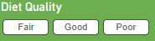

- Part Time Job Filter
Used the Slicer Visual.
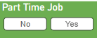

- Age with Slicer Visual
Used the Slicer Visual.
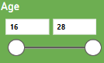

- Extra Curriculum Activities Filter
Used the Slicer Visual.
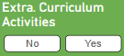

- Learning Style Filter
Used the Slicer Visual.
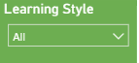

Different Visuals to get the meaningful visualization in Power BI

- Stress Level Details of Students
Showing the Result for Stress Level of Students Dataset:

Created the new conditional Column for Stress Status to find the level of stress of students.

Stress Status = IF(
'Student Habits and Academic Per'[stress_level] >= 7 , "High", if('Student Habits and Academic Per'[stress_level]>=5, "Medium",

"Low"
))
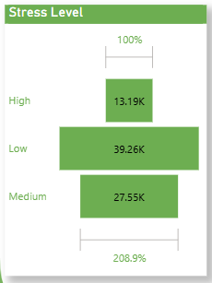

- Semester wise Details
Showing the Result for Semester wise Details Level of Students Dataset:
Created the new conditional Column for SemesterName to get the Semester Name as Semester 1, Semester 2 and so on.
SemesterName = "Semester" & " " & 'Student Habits and Academic Per'[semester]

Created the TreeMap for getting the Semester wise Details

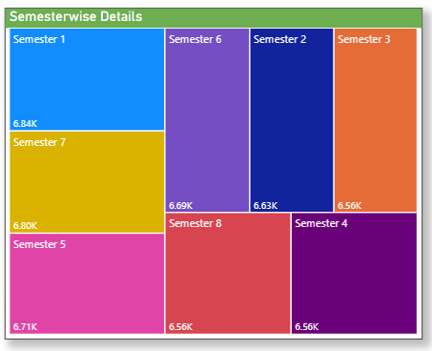

- Attendance Details by Gender

Showing the Result of Attendance Details by Gender from Student Dataset:

Used here the Pie Chart to demonstrate the Attendance Details by Gender
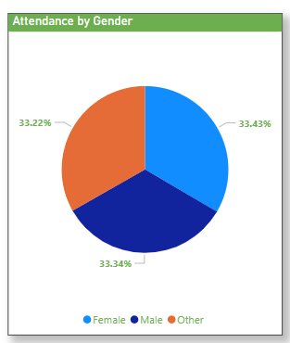

- Study Environment Details
Showing the Result of Study Environment Details from Student Dataset:
Used here the Water Fall Chart to demonstrate the Study Environment Details.
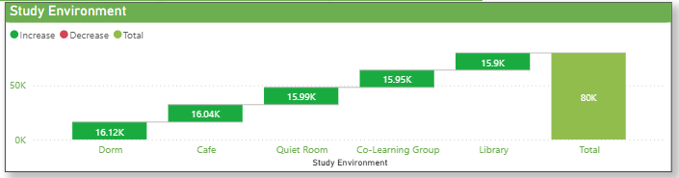

- Extra-Curriculum Activities Details
Showing the Result of Extra-Curriculum Activities Details from Student Dataset:
Used here the Water Fall Chart to demonstrate the Extra-Curriculum Activities Details.
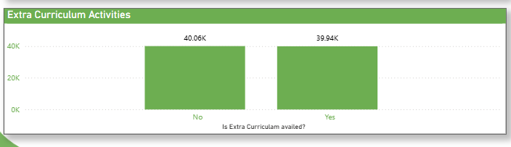

- Major Subjects Details:
Showing the Result of Major Subjects Details along with Part Time Job Details from Student Dataset.
Used here the Matrix to demonstrate the Major Subjects Details.
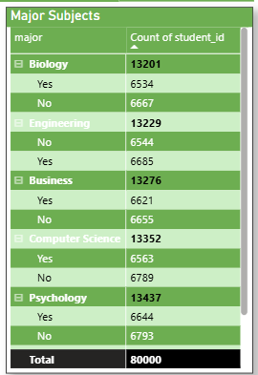

- Diet Quality Details
Showing the Result of Diet Quality Details from Student Dataset.
Used here the Donut Chart to demonstrate the Diet Quality Details

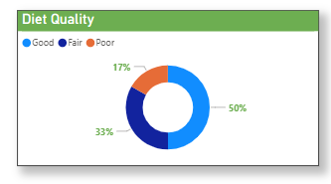

- Major Subjects Details
Showing the Result of Major Subjects Details from Student Dataset.
Used here the WordCloud Chart to demonstrate the Major Subjects Details

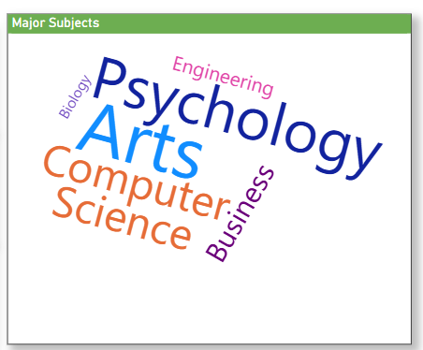

- Attendance Card Details with status of Poor/Average/Good
Showing the Result of Attendance in Card form from Student Dataset which are coming from different measures which are given below:
Good Attendance =
CALCULATE(
COUNT('Student Habits and Academic Per'[Attendance Status]),
'Student Habits and Academic Per'[Attendance Status] = "Good"
)
Average Attendance =
CALCULATE(
COUNT('Student Habits and Academic Per'[Attendance Status]),
'Student Habits and Academic Per'[Attendance Status] = "Average"
)
Poor Attendance =
CALCULATE(
COUNT('Student Habits and Academic Per'[Attendance Status]),
'Student Habits and Academic Per'[Attendance Status] = "Poor"
)

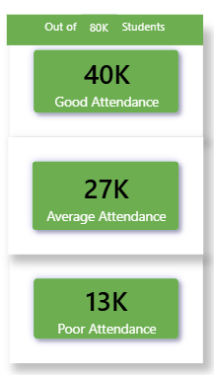

- Reset All Filters Button
Given option to clear the filters on their default stage and used the .png image given below and created the bookmark for them and apply on this reset button too.
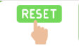

- NextPage/Previous page Buttons
For moving the next page, given provision to go to next page as well as previous page by creating the next and previous page image.



Different Visuals are altogether in 3 different Dashboard in Power BI

- Dashboard 1

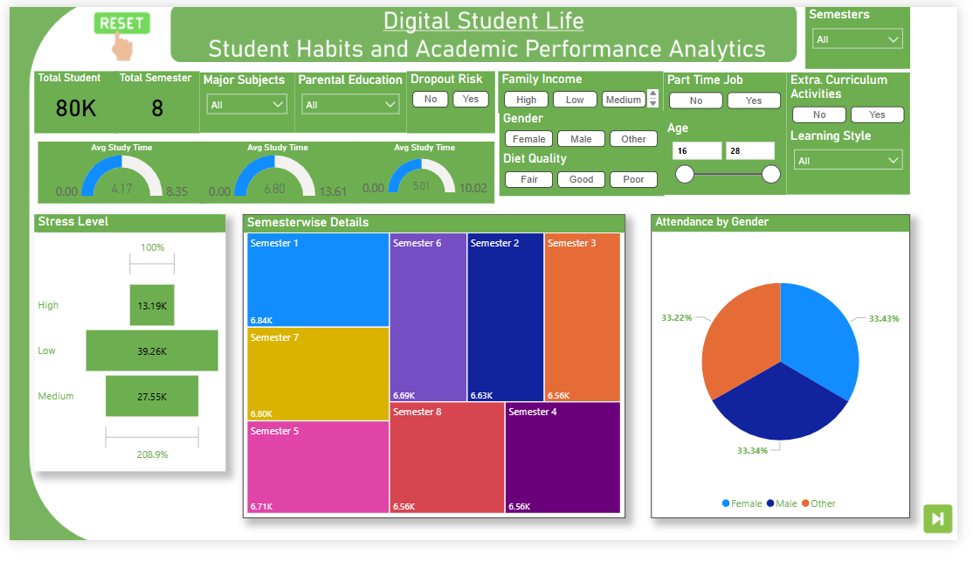

- Dashboard 2

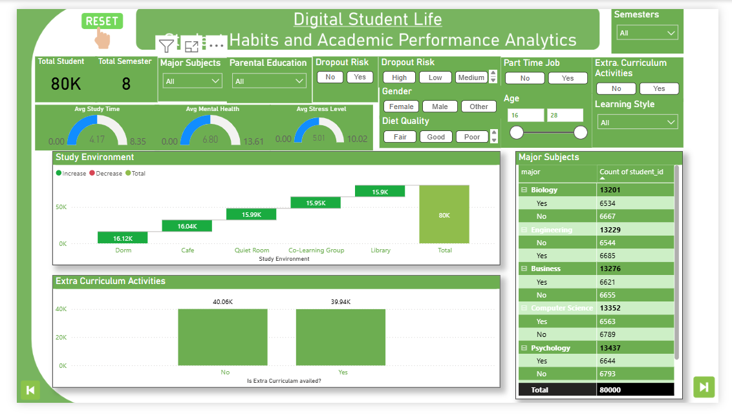

- Dashboard 3

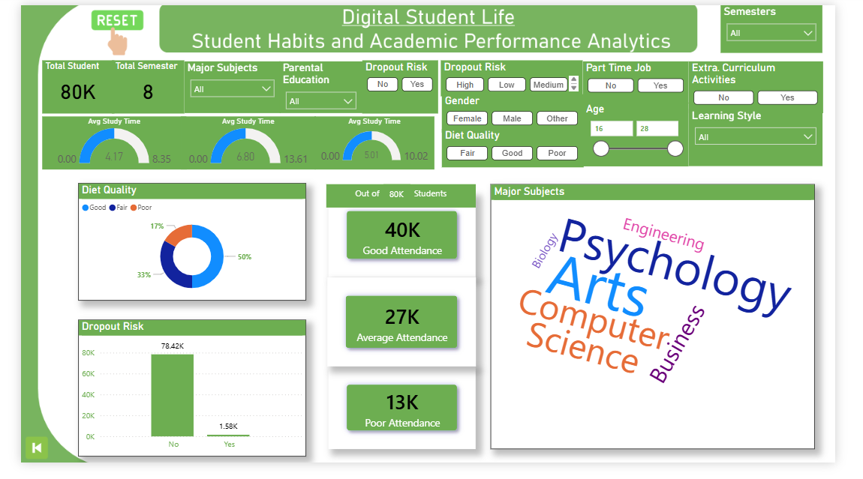

Thank you

